**Step1:** Select the bucket you want to set up lifecycle rule for and click on it.

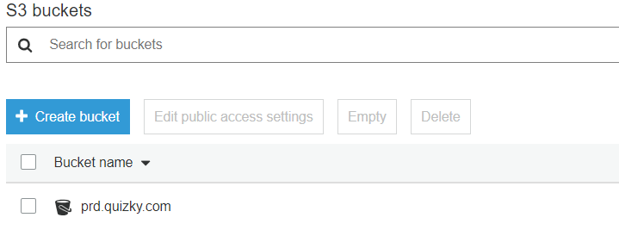

**Step 2:** Click on Management and then click on add Lifecycle rule button.

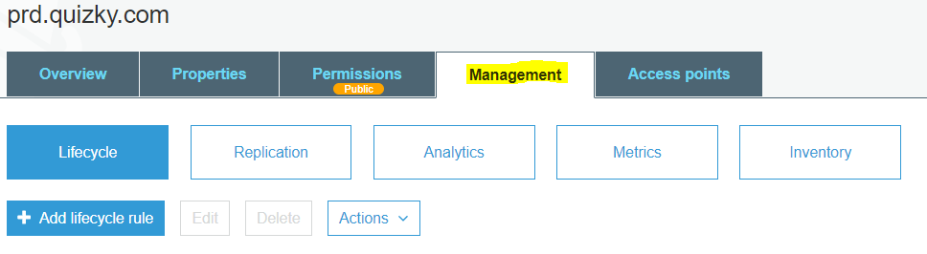

**Step 3:** Then type the rule name and add Prefixes or Tags if necessary.

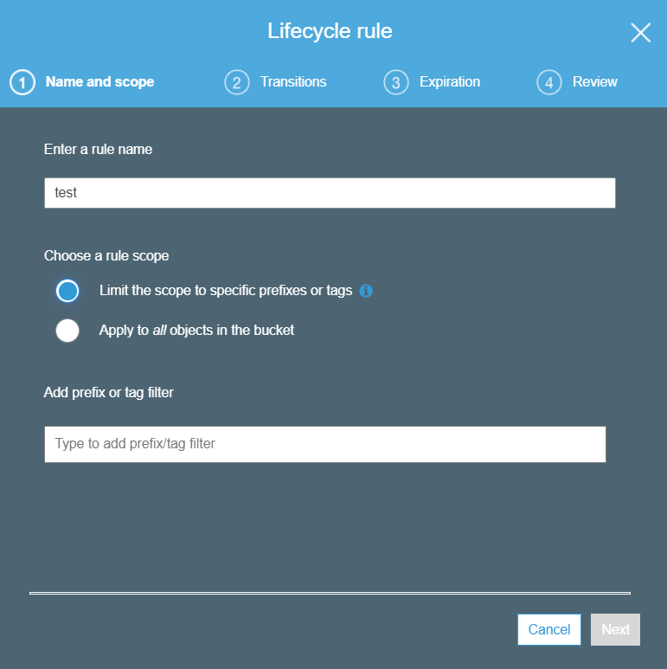

**Step 4:** Then check the versions of the data which you want to be transferred with Lifecycle rule, then click on +Add transition button then select Transition to Amazon Glacier after and specify the required amount of days.

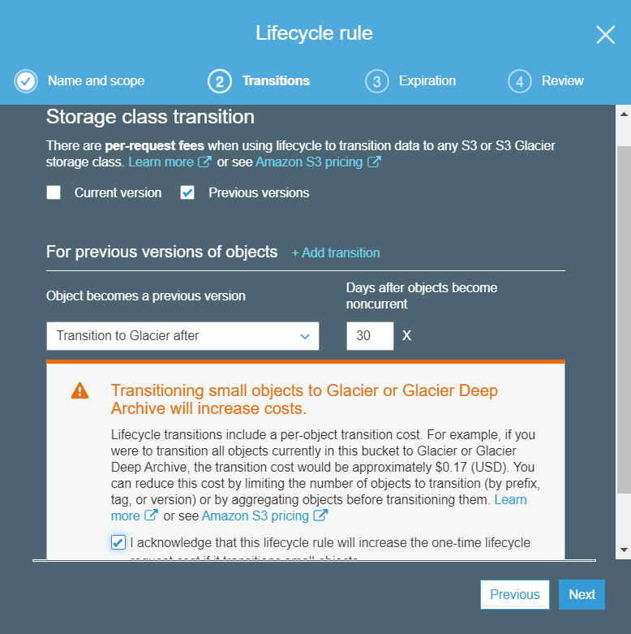

just skip it and click Next. (This step is setup to Permanently delete files from S3 after given days.)

**Step 5:** Since the lifecycle is set up for the bucket in S3, you can just skip this expiration Tab it and click **Next**.

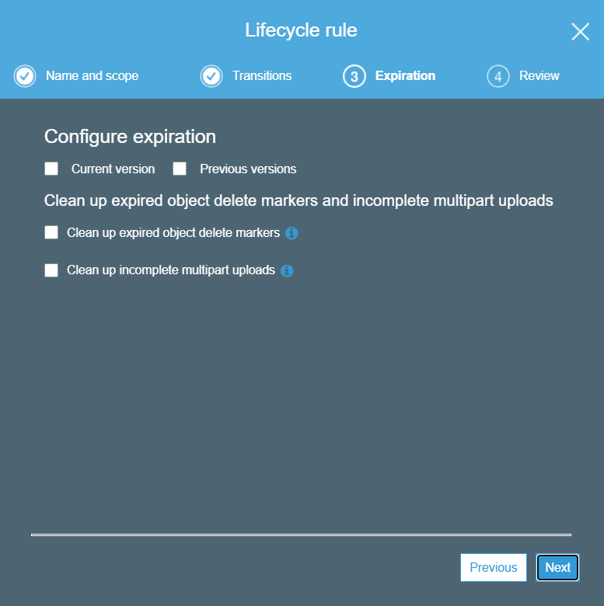

**Step 6**: Review the rule which you have created and click on save.

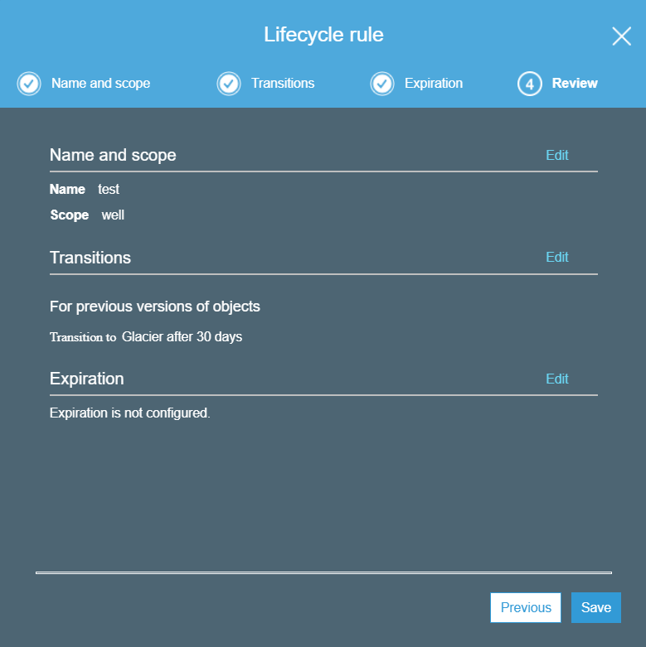

**Step 7:** Now you can see Lifecycle rule is applied on your selected bucket.

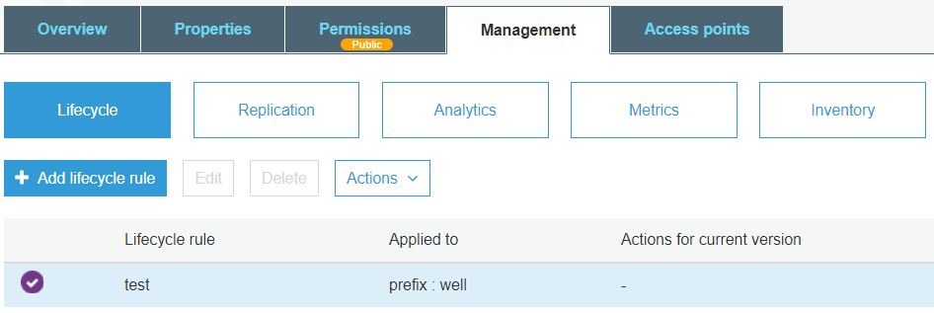

**Step 8:** We can enable and disable the Lifecycle policy whenever we want.

